NAME – VISHAL RAJ
USN – 1NT19IS190

BIG DATA LAB 20/05/2022

mongo version

MongoDB server version: 5.0.1

mongo

create the database

use vishalraj

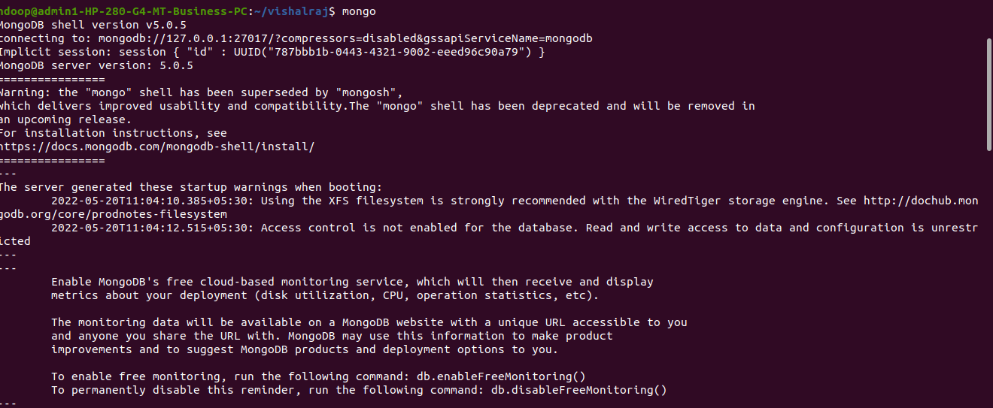
to show all the databases
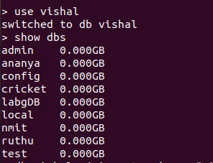

to insert the data we use:
db.vishalraj.insertOne({name:"vishal",dept:"ise"})

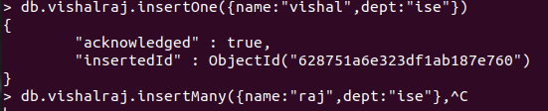

to insert many data at a time we will use:
db.vishalraj.insertMany([{name:"raj",dept:"ise"},{name:"suman",dept:"ise")]}

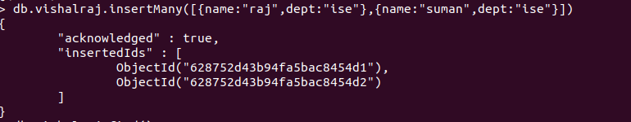
TO FIND THE DATA WE USE
db.vishalraj.find();
OR
db.vishalraj.find().pretty();

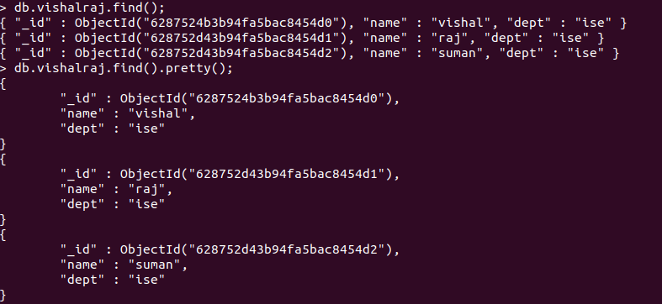
TO UPDATE WE WILL USE
db.vishalraj.updateOne({"name":"suman"},{$set:{"dept":"ise"}})

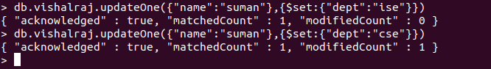
TO DELETE WE WILL USE
db.vishalraj.deleteOne({name:"vishal"})

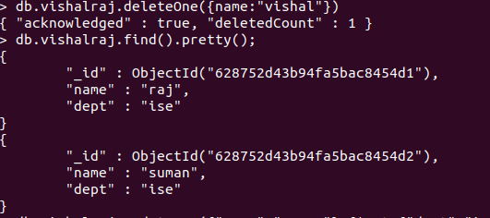

TO USE OR COMMAND WE USE:
db.vishalraj.find({$or:[{"dept":"ise"},{"dept":"cse"}]}).pretty()
